S02-Generate Selenium Code --Classroom Session Practice

Postman
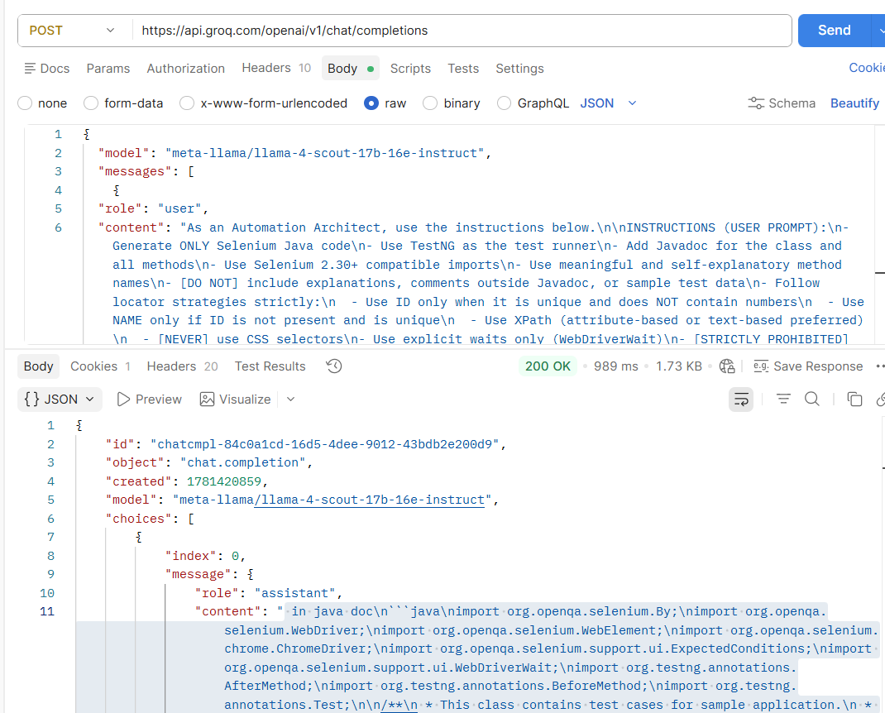

JSON to Text Formatter
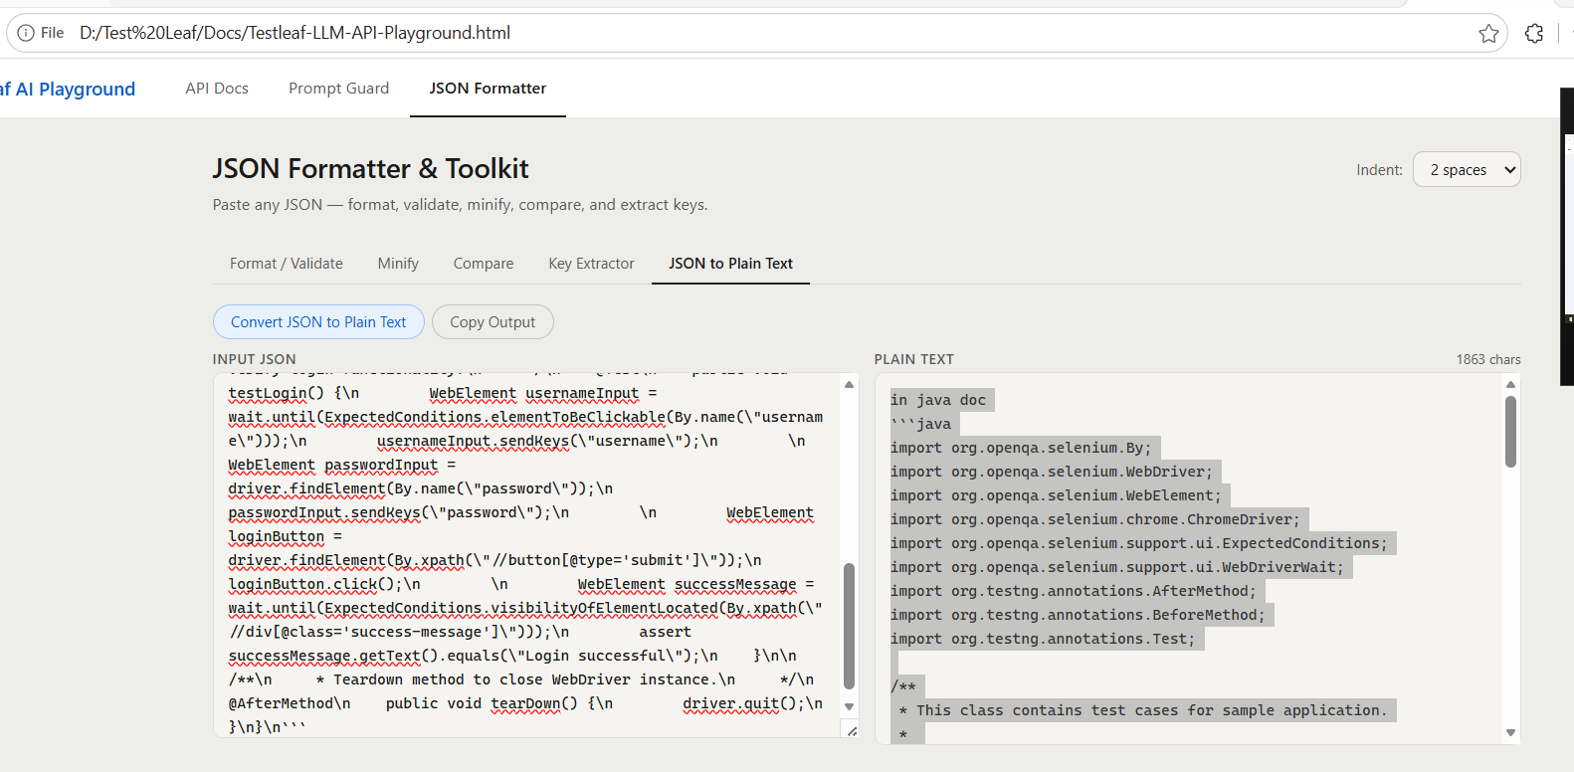

Jave Code:
import org.openqa.selenium.By;
import org.openqa.selenium.WebDriver;
import org.openqa.selenium.WebElement;
import org.openqa.selenium.chrome.ChromeDriver;
import org.openqa.selenium.support.ui.ExpectedConditions;
import org.openqa.selenium.support.ui.WebDriverWait;
import org.testng.annotations.AfterMethod;
import org.testng.annotations.BeforeMethod;
import org.testng.annotations.Test;

/**
* This class contains test cases for sample application.
*
* @author [Your Name]
*/
public class SampleTest {

WebDriver driver;
WebDriverWait wait;

/**
* Setup method to initialize WebDriver and navigate to application URL.
*/
@BeforeMethod
public void setup() {
System.setProperty("webdriver.chrome.driver", "/path/to/chromedriver");
driver = new ChromeDriver();
driver.manage().window().maximize();
driver.get("https://www.sample.com");
wait = new WebDriverWait(driver, 10);
}

/**
* Test case to verify login functionality.
*/
@Test
public void testLogin() {
WebElement usernameInput = wait.until(ExpectedConditions.elementToBeClickable(By.name("username")));
usernameInput.sendKeys("username");

WebElement passwordInput = driver.findElement(By.name("password"));
passwordInput.sendKeys("password");

WebElement loginButton = driver.findElement(By.xpath("//button[@type='submit']"));
loginButton.click();

WebElement successMessage = wait.until(ExpectedConditions.visibilityOfElementLocated(By.xpath("//div[@class='success-message']")));
assert successMessage.getText().equals("Login successful");
}

/**
* Teardown method to close WebDriver instance.
*/
@AfterMethod
public void tearDown() {
driver.quit();
}
}

S09- TextFromImage-base64

Image
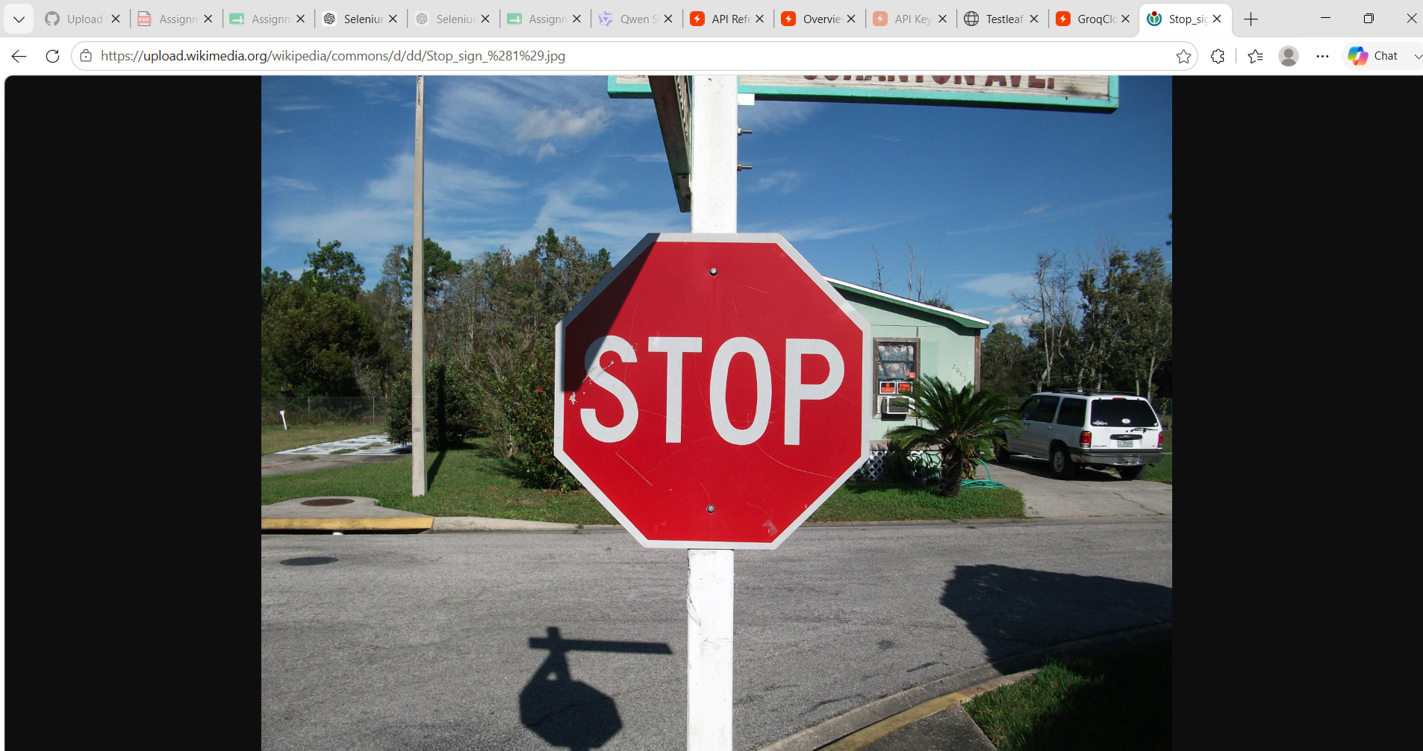

Postman Output
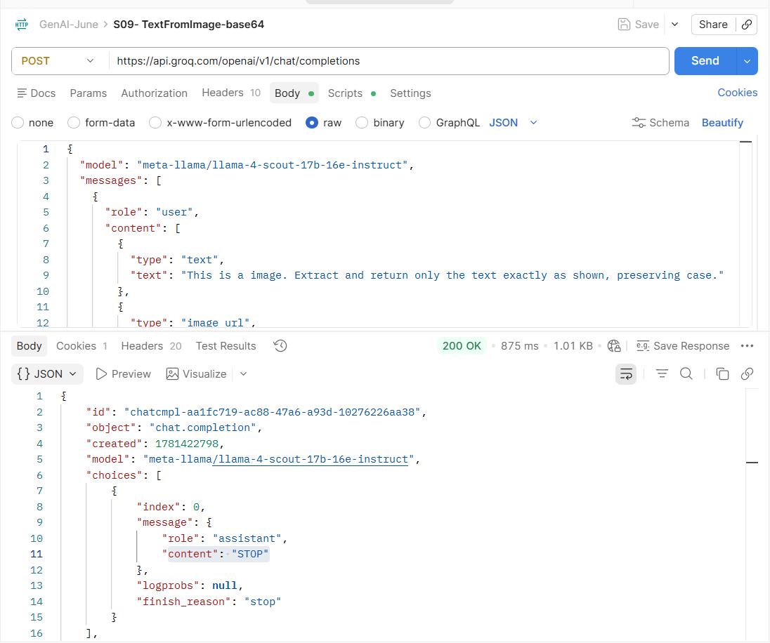

Pre Script
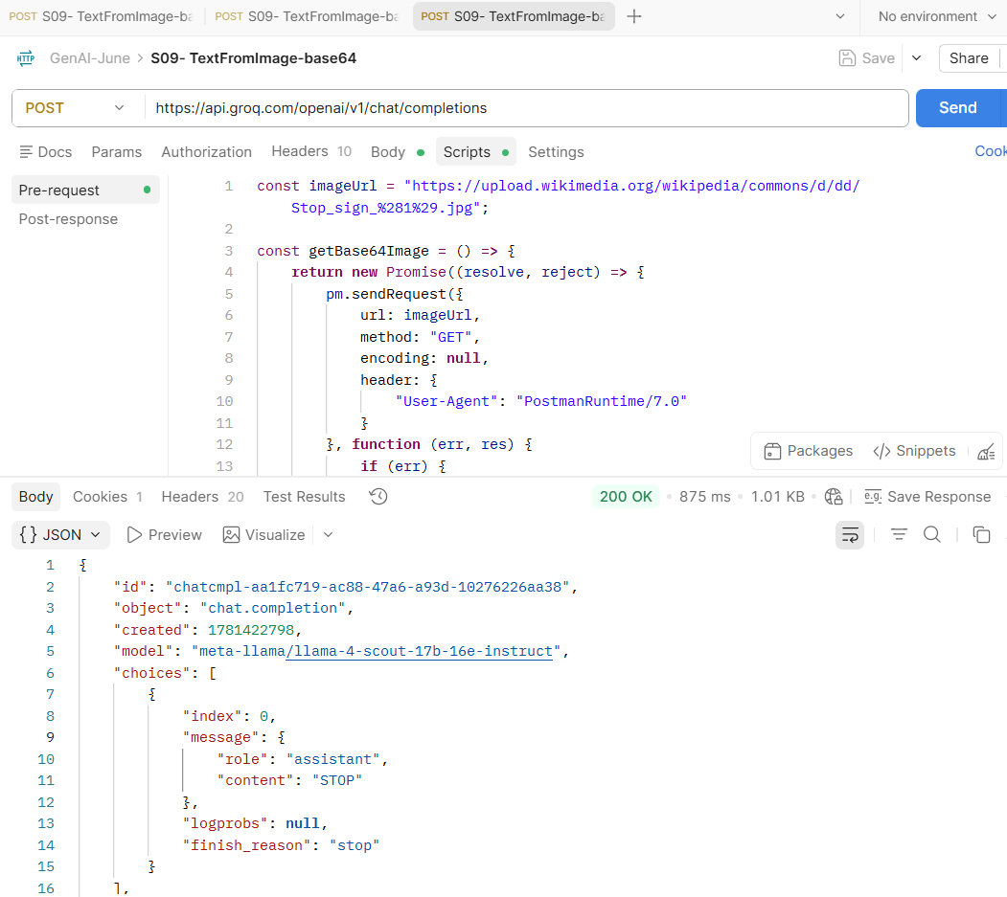

S02- MultiLingual

Postman

Tamil
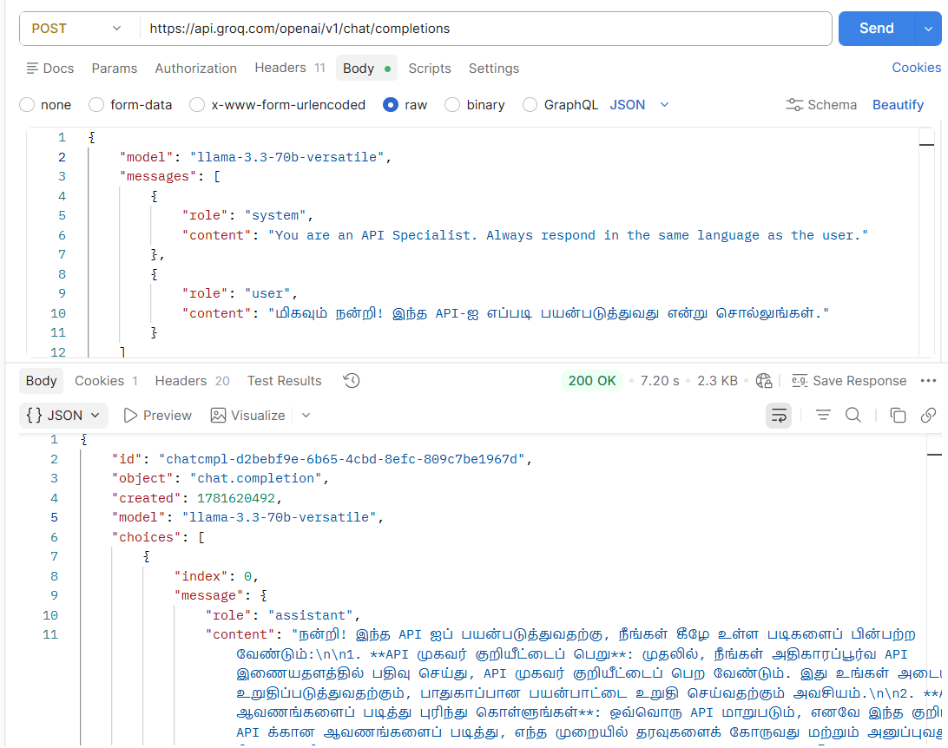

English
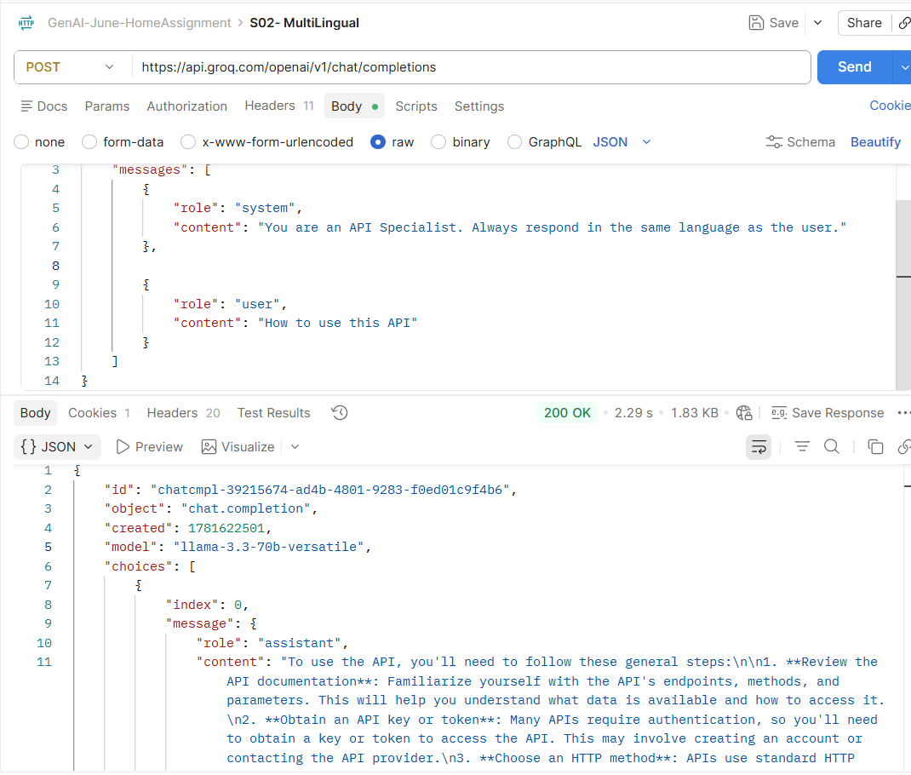

Telugu
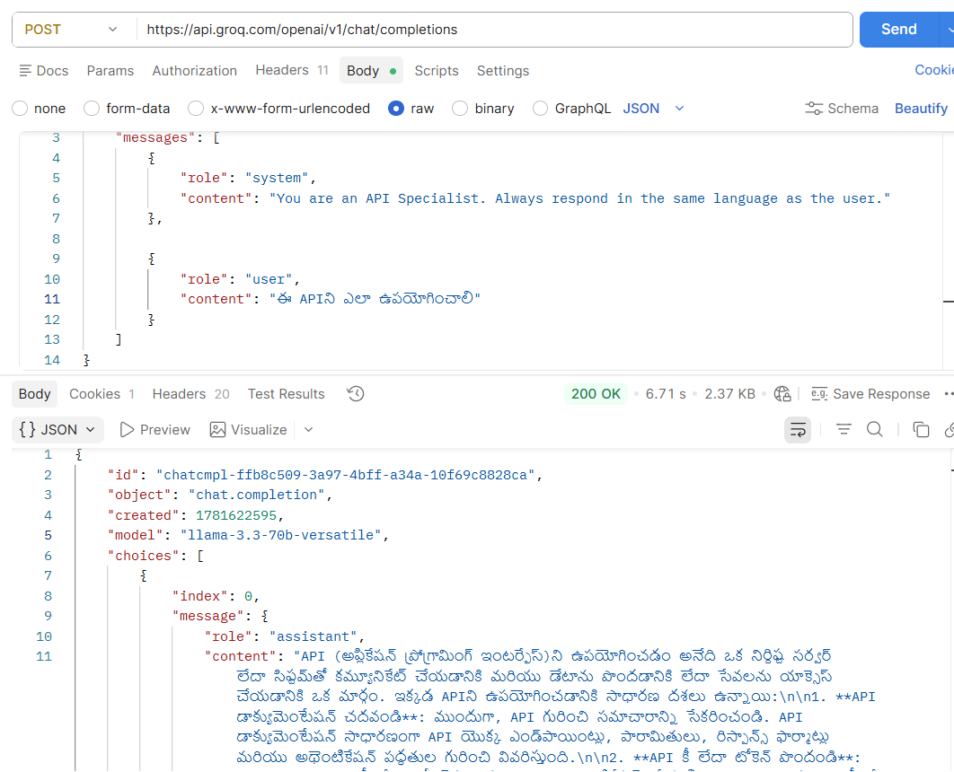

S01-Text to Audio
